Group Project – THE LIFE OF NIKOLA TESLA
Ashley Tuckett
Instructor Max Weiss
Physics 1010
5 August 2013

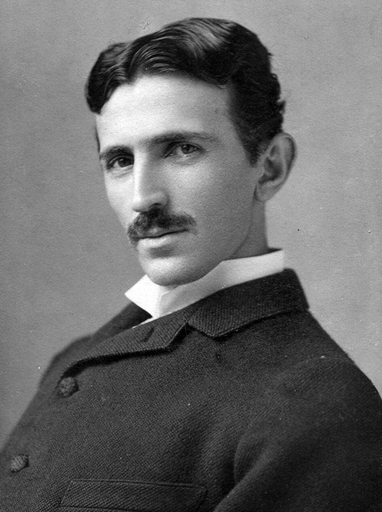

On July 10, 1856 Nikola Tesla was born in the middle of a violent lightning storm (8 Things You Didn’t Know About Nikola Tesla), in the mountainous region of the Balkan Peninsula known as Lika, in what was then the Austro-Hungarian Empire (Tesla Life and Legacy – Tesla’s Early Years). During his birth, according to a family legend, the midwife stated that the storm was a bad omen and that the baby would be a child of darkness. To that, his mother replied, “[n]o. He will be a child of light” (8 Things You Didn’t Know About Nikola Tesla).
Tesla’s father, Milutin, was a Serbian Orthodox priest, as well as a writer and a poet (8 Things You Didn’t Know About Nikola Tesla). His mother Djuka, who was also Serbian, was a bit of an inventor herself. She created several household appliances to help with the work around the family farm, one of which included a mechanical eggbeater, and she is who Tesla accredits for his inventive disposition (Tesla Life and Legacy – Tesla’s Early Years). Tesla also had a brother, named Daniel, who was killed in a riding accident when Tesla was only seven years old (Nikola Tesla, History). It is reported that his brother’s death shocked and disturbed Tesla so much, that he began to have visions (Nikola Tesla, History). It is also reported that Tesla had alarmingly vivid nightmares as a child (8 Things You Didn’t Know About Nikola Tesla).
Growing up, Tesla had a passion for math and science. He was even able to perform integral calculus in his head, which led many of his teachers to believe that he was cheating (Tesla Life and Legacy – Tesla’s Early Years). Tesla also had a photographic memory, and was able to memorize entire books as well as images (8 Things You Didn’t Know About Nikola Tesla). Because of his passion for math and science, Tesla wanted to become an engineer, but was always pressured by his father to follow in his footsteps and join the priesthood. It wasn’t until Tesla was seventeen and suffering from a near-fatal bout of cholera, that he was able to convince his father to let him attend the Austrian Polytechnic School at Graz to study engineering (Tesla Life and Legacy – Tesla’s Early Years). His bout with cholera also led him to develop the excessive hygiene habits that he was known for (8 Things You Didn’t Know About Nikola Tesla).
Tesla attended the Austrian Polytechnic School from 1875 to 1878. During his second year there, he was at a lecture given by a professor Poeschl, who demonstrated a dynamo operating as a motor and a generator. This demonstration gave Tesla his first idea for an alternating current motor without commutators and brushes (Nikola Tesla, MIT).
In 1879, Tesla got his first job at a technical firm in Maribor, Slovenia as an assistant engineer. Also during this time, Tesla completed his education at the University of Prague (Nikola Tesla, MIT). In the years of 1881 and 1882, Tesla invented an apparatus that amplifies sound for telephone while he was working in Budapest as an engineer with the Central Telegraph Office (Nikola Tesla, MIT). In the fall of 1882, Tesla went to Paris and got a position with the Continental Edison Company. During his employment with the Continental Edison Company, Tesla went on assignment to Strasbourg to help with the running of a new electric power plant that had been damaged in a trial run (Nikola Tesla, MIT). While he was in Strasbourg, Tesla constructs the first prototype for his induction motor (Nikola Tesla, MIT).
At the age of 28 in 1884, Tesla came to New York City with only four cents in his pocket, a few mathematical calculations, a drawing of an invention for a flying machine and a letter of recommendation (Tesla Life and Legacy – Coming to America). This letter of recommendation was written to Thomas Edison by Charles Batchelor, one of his business associates in Europe. In the letter, Batchelor had written "[m]y Dear Edison: I know two great men and you are one of them. The other is this young man!" (Tesla Life and Legacy – Coming to America). With this, Edison hired Tesla to make improvements to his direct current generation plants, and Tesla claimed that Edison offered him $50,000 if he were to succeed. While working at Edison Machine Works, Tesla alleged that his working hours were 10:30 a.m. to 5 a.m. the following day (Tesla Life and Legacy – Coming to America). After several months working for Edison, Tesla successfully completed his work and asked Edison to be paid. Edison responded by saying that the offer of $50,000 had been made in jest and informed Tesla that “[w]hen you become a full-fledged American you will appreciate an American joke” (Tesla Life and Legacy – Coming to America). Following that incident, Tesla resigned from his position at Edison Machine Works.
In 1888, Tesla went to work for George Westinghouse, who was an industrialist, inventor, corporate entrepreneur, and rival of Thomas Edison. Westinghouse had also bought Tesla’s 40 U.S. patents for the “polyphase alternating current system of generators, motors, and transformers” (Tesla). Working for Westinghouse, Tesla was able to develop the alternating current system.
In 1893, Tesla and Westinghouse were able to display the advantages of using alternating current to power electric lights and appliances, with Westinghouse’s winning bid to power the Columbian Exposition in Chicago (Tesla). This display convinced the investor J.P. Morgan to financially back Westinghouse and Tesla in the creation of the first hydroelectric power plant at Niagara Falls, which was built in 1895 (Tesla).
The year 1899 was when Tesla moved to Colorado Springs, Colorado in order to work on a high voltage, high frequency tower for the U.S. government (Tesla). While in Colorado Springs, Tesla discovered terrestrial stationary waves, with which he proved that the Earth could be used as a conductor (Tesla Biography). Also while he was in Colorado Springs, Tesla was able to light 200 lamps from a distance of 25 miles (Tesla Biography). In 1900, Tesla returned to New York City, and after returning, was able to get financial backing from J.P. Morgan to build a transmission tower and power plant (Tesla Life and Legacy – Tower of Dreams). J.P. Morgan withdrew his financial backing of Tesla when he discovered that the wireless transmission system that Tesla was working on would provide “free” wireless electricity for everyone (Tesla).
The years following the loss of J.P. Morgan’s financial backing brought no great prospects for Tesla although he was always inventing, and in 1922 at the age of 65, Tesla managed to make a living by working as a consulting engineer (Tesla Life and Legacy – Poet and Visionary). In the last decades of Tesla’s life he lived in the New Yorker hotel, and he continued inventing even as his mental health and energy were failing him (Nikola Tesla, History). Besides inventing, Tesla also spent his final years feeding the pigeons of the city. On January 7, 1943 at the age of 86 Tesla died in his hotel room of coronary thrombosis. Because he spent his life inventing, Tesla never married. Also upon his death, Tesla held over 700 patents (Tesla).
Bibliography
Jacobson, Rebecca. “8 Things You Didn’t Know About Nikola Tesla.” Pbs.org. N.p. 10 July 2013. Web. 29 July 2013. http://www.pbs.org/newshour/rundown/2013/07/5-things-you- didnt-know-about-nikola-tesla.html
“Nikola Tesla.” History.com. A&E Television Networks, LLC. N.d. Web. 29 July 2013. http://www.history.com/topics/nikola-tesla
“Nikola Tesla.” Mit.edu. N.p. N.d. Web. 29 July 2013. http://www.mit.edu/~most/ser/Tesla1/etradict2.htm
Schwartz, Shelly. “Tesla: A Biography of Inventor Nikola Tesla.” About.com. About.com. N.d. Web. 29 July 2013. http://history1900s.about.com/od/people/a/Tesla.htm
Vujovic, Ljubo. “Tesla Biography: Nikola Tesla the Genius Who Lit the World.” Teslasociety.com. Tesla Memorial Society. 10 July 1998. Web. 29 July 2013. http://www.teslasociety.com/biography.htm
“Tesla Life and Legacy – Tesla’s Early Years, Coming to America, Tower of Dreams, Poet and Visionary.” Pbs.org. N.p. N.d. Web. 29 July 2013. http://www.pbs.org/tesla/ll/ll_early.html

